**FONTS ICONS / IMAGES**

**Installation**

1. Copy **com.temenos.widgets.font.images** folder in your widgets folder (Ex: /{your project/templates/widgets/ })
2. Copy the content of the widget.xml file into your project **widgets.xml** file

**How to use**

1. You will have to add a new Display Type -> Font-Images in your presentation.
2. Within Widget Details tab you have to set up the widget settings .

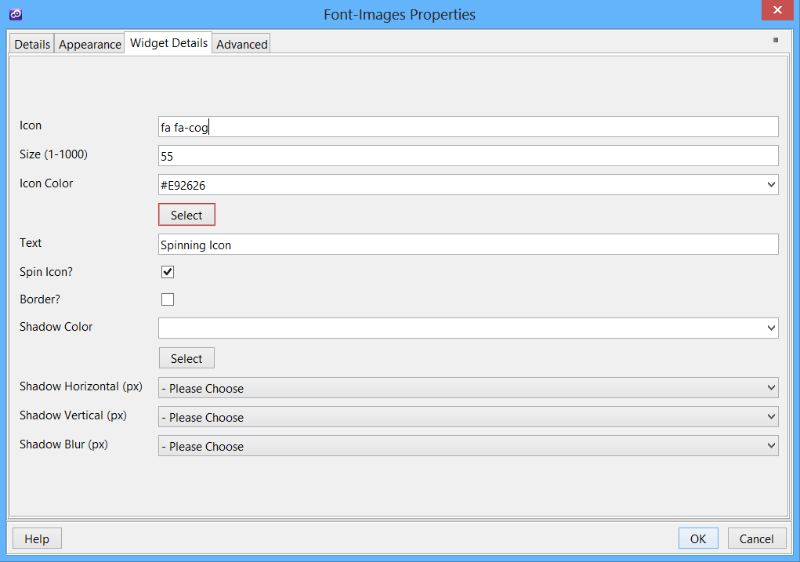

* **Icon** – The name of the icon. You can see a full list of the naming at <http://fortawesome.github.io/Font-Awesome/icons/>
* **Size** – The size of the icon in pixels
* **Icon Color** – Select the color of the icon
* **Text** – Add a text on the right side of the icon
* **Spin Icon** – Add a spinning effect to the icon
* **Border** – Add a border to the icon
* **Shadow Color** – Automatically add a shadow and select the color
* **Shadow Horizontal** – Select the size of the horizontal shadow
* **Shadow Vertical**– Select the size of the vertical shadow
* **Shadow Blur** – Select blue size

**How it’s works**

The widget will add a <i></i> snippet for the icon and will generate a text (optional) with the content based on the user selection within the Widget Details configuration tab.

**Result**

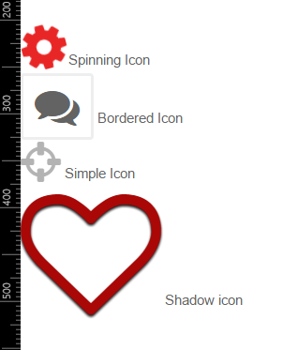

**Supported Platforms**

* All browsers (Desktop & Mobile)